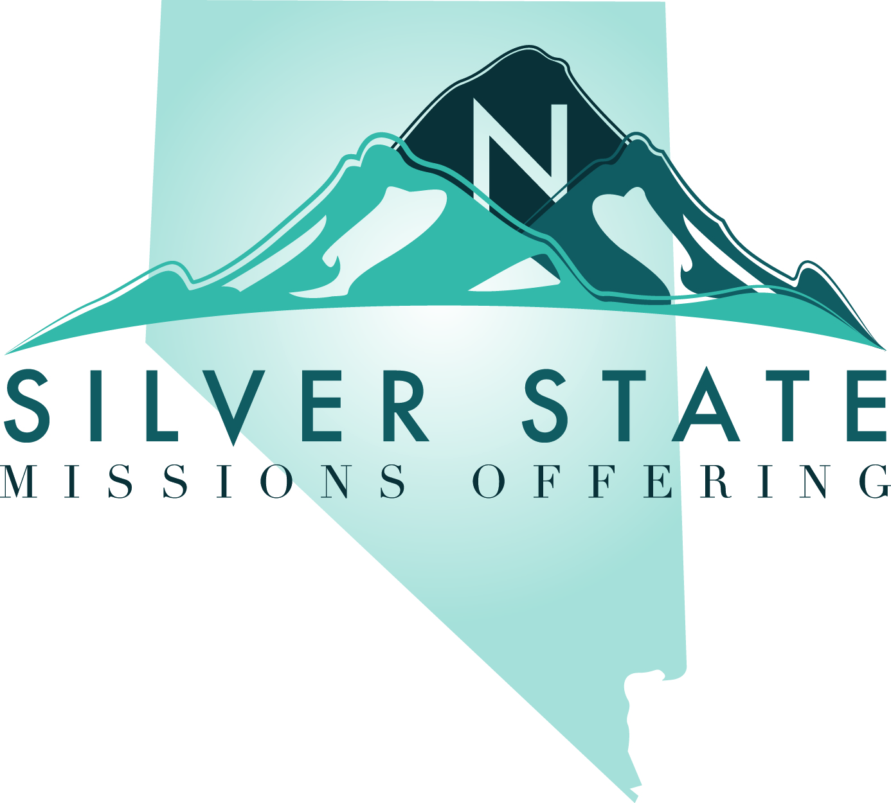
Silver State Missions Offering Funds Request

Church Name __________________________________________________________________

Address_______________________________________________________________________

City ________________________ Zip ____________ Phone ________________________

Contact Person _________________________________________________________________

Phone and e-mail for contact ______________________________________________________

What is the intended use for the funds being requested? _______________________________ ______________________________________________________________________________Total cost of event: $ ___________ Date of event: _______________________
Amount of assistance needed: $ ___________
Please give an itemized list with dollar amounts of how the funds will be spent:

What are your goals for this event?

What is your follow-up plan after the event?

Criteria for receiving funds from the SSMO:
€ The requesting church is an active member in the Nevada Baptist Convention.
€ The requesting church has contributed to the SSMO offering and CP in the past or plans
to do so soon.
€ The requesting church agrees to report to NBC on how the SSMO funds helped the
church in its ministry goals.

Please return by mail, e-mail or fax to: Nevada Baptist Convention
Attn: Vanessa Stricker
406 California Avenue, Reno, NV 89509
phone: 775.786.0406 fax: 775.786.0700
vstricker@nevadabaptistconvention.org

